**PARTNERSHIP**

**HISPANIC DISCUSSION WORKSHOP ORGANIZED BY iGEM BOLIVIA**

MOTIVATION.

PARTNERSHIP

Hispanic Discussion Workshop

Handbook “iGEM from Begginers”

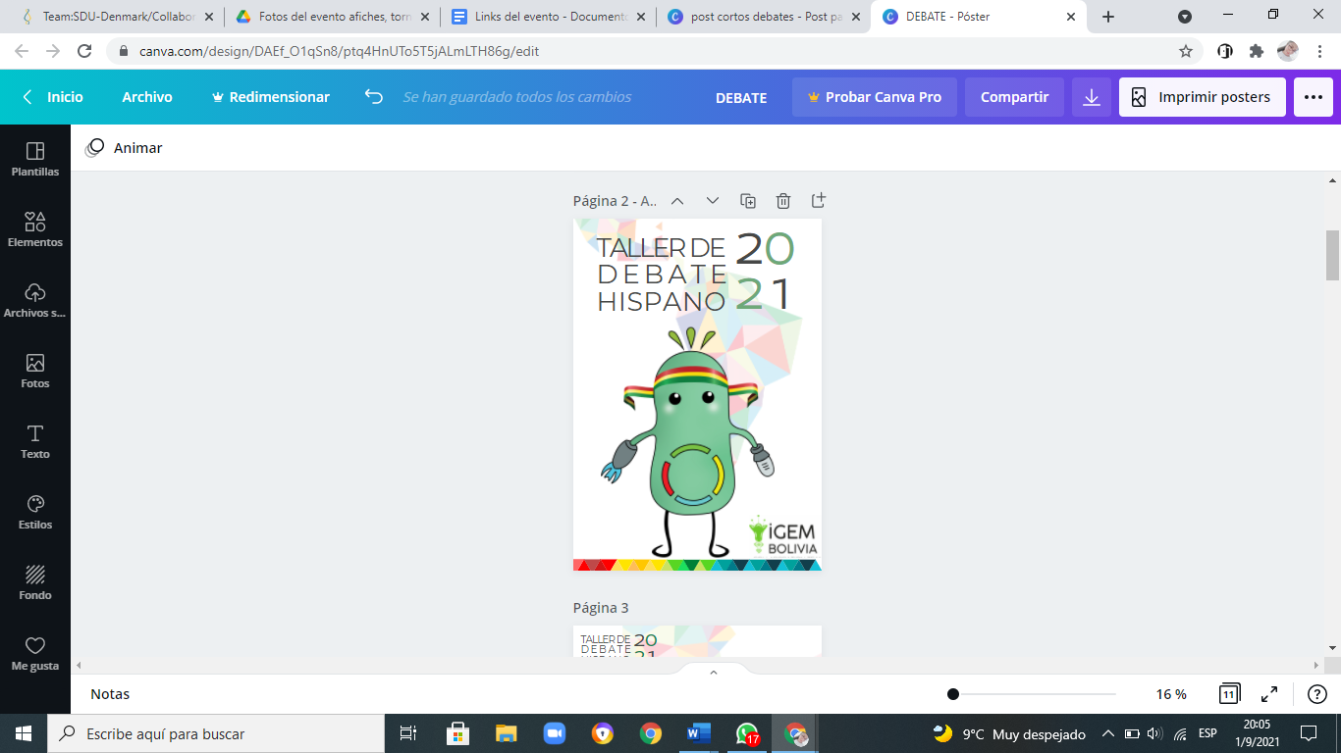iGEM Bolivia began with the debates in 2020, where it emerged as an idea to start dealing with controversial issues around synthetic biology and to be able to analyze different points of view. In the same year some iGEMers learned techniques and tools necessary in a debate, this thanks to the Debate School. Already for the year 2021 we were able to organize an event at the Latin American level where we could share the knowledge that was acquired a year ago and invite teachers, so they can give the workshop, and iGEM teams, so they can learn more about these tools and be able to contrast opposing thoughts in a more logical, collaborative and orderly way.

OBJECTIVE

The main objective of this activity was to encourage young people in Latin America to develop rhetoric and critical thinking skills to analyze controversial topics related to synthetic biology and thus reach a more complete synthesis of thought, always based on documented information.

* TEAMS

ABOUT THE EVENT

To start with this great event, we needed the help of other teams, who responded to our call and with whom we could work over a month and meet common objectives, communicate science differently through debate. iGEM Ecuador, iGEM FCB - UANL and iGEM UAM.

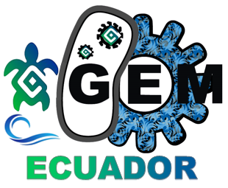



* INSTRUCTORS

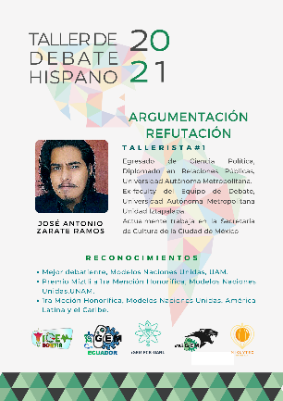 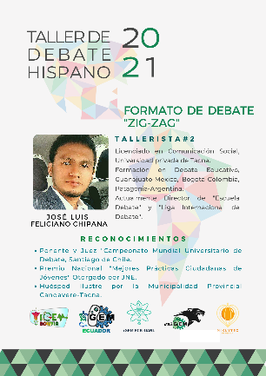 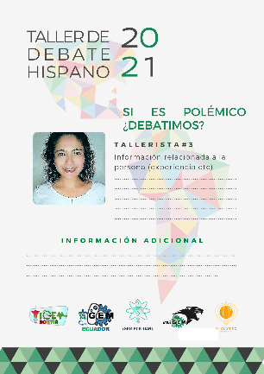

PARTNERSHIP

Hispanic Discussion Workshop

Handbook “iGEM from Begginers”

We started with three workshops in which all participants were able to interact and learn the necessary tools in a debate:

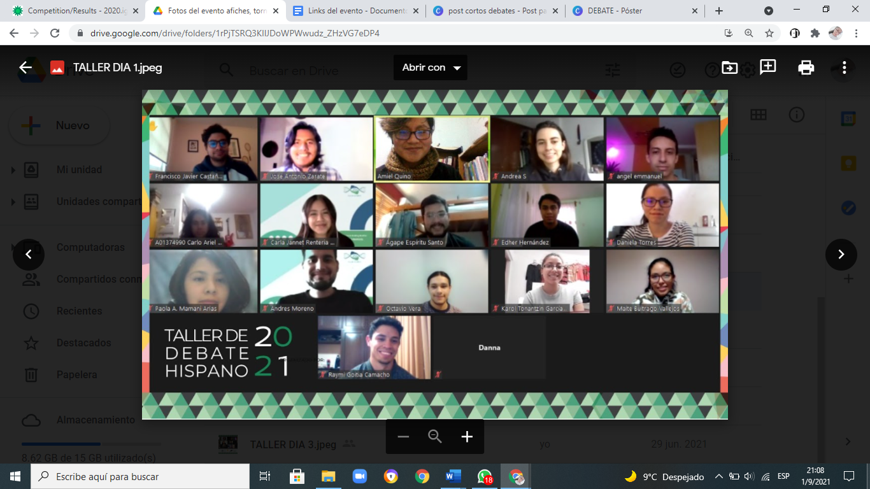"Argumentation and Counterargumentation" taught by Antonio Zarate Ramos. Where the bases of argumentation and dialectics were seen. It closed with a very dynamic and interactive activity where they put into practice what they learned.

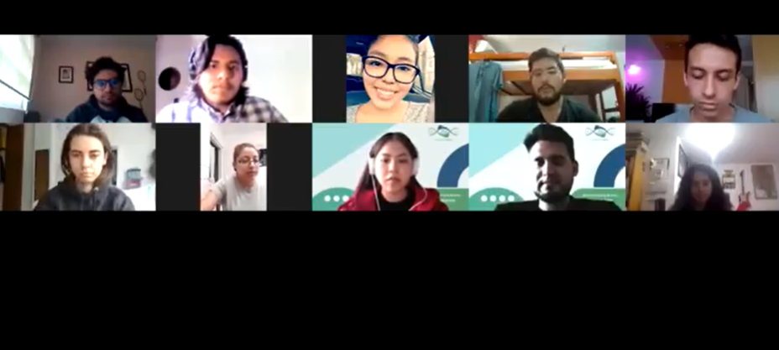

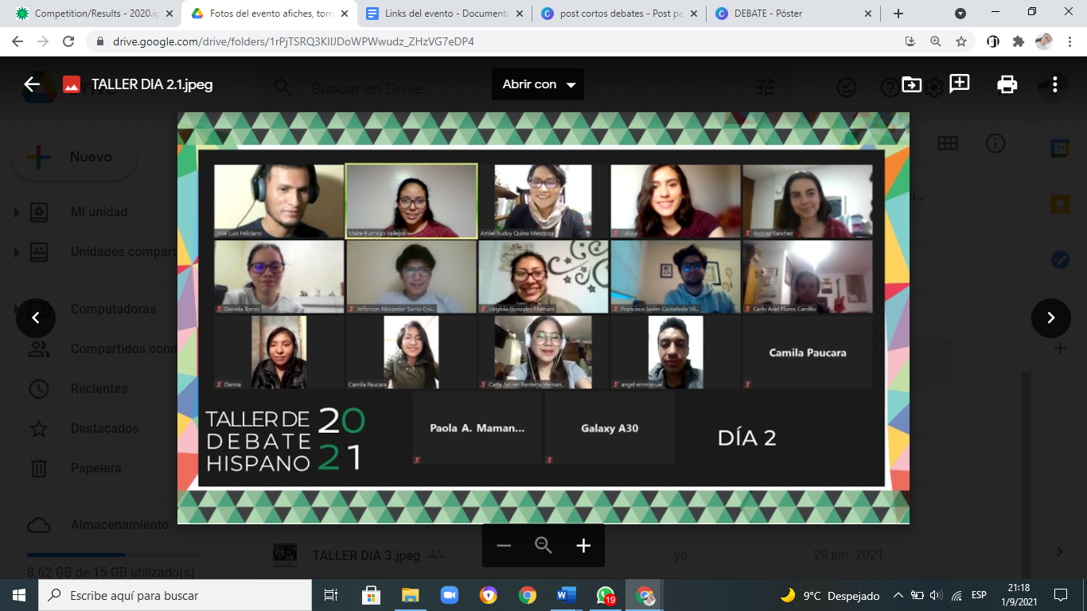"Roles of Judges and Zigzag Format" taught by Mr. José Luis Feliciano Chipana, a very important topic when it comes to participating as a judge or speaker in a debate. Ending with a mock debate in this format.

"If knowledge is Controversial, do we debate?"Together with MSc. Gabriela Rivadeneira Caballero tutor of iGEM BOLIVIA, who spoke to us about how to convey our ideas regarding the position of an issue. He mentioned that

PARTNERSHIP

Hispanic Discussion Workshop

Handbook “iGEM from Begginers”

*" ... we must notice the culture, be able to transmit scientific knowledge to a target group, we will see that knowledge becomes controversial and we have the challenge of being able to transmit this scientific knowledge in a friendly way.”*

*---MSc. Gabriela Rivadeneira.*

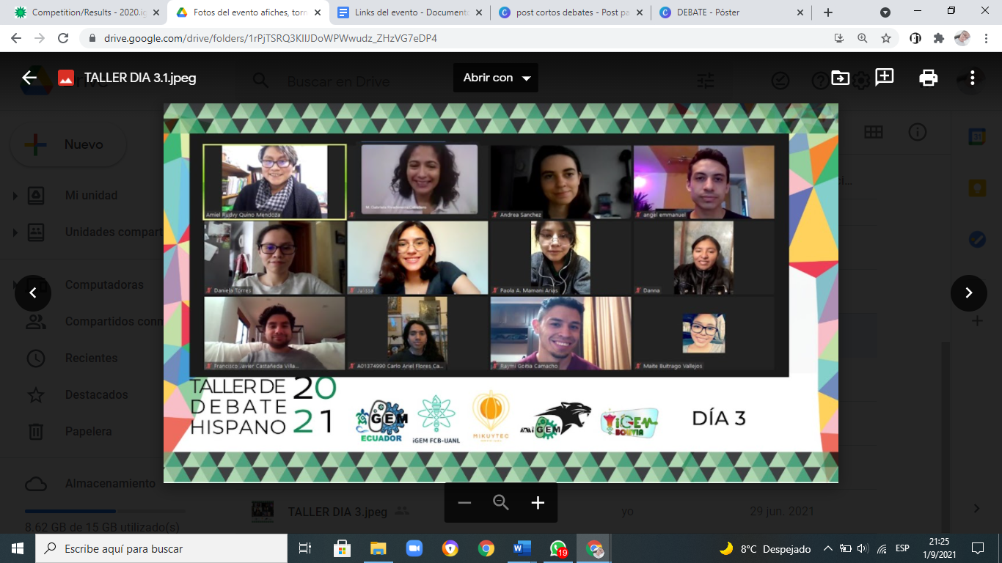

ABOUT THE TOURNAMENT

The Debate Tournament was held on Saturday June 19 and Sunday June 20, where a total of 8 teams participated. From this first tournament we obtained the semifinalists who debated the following motions:

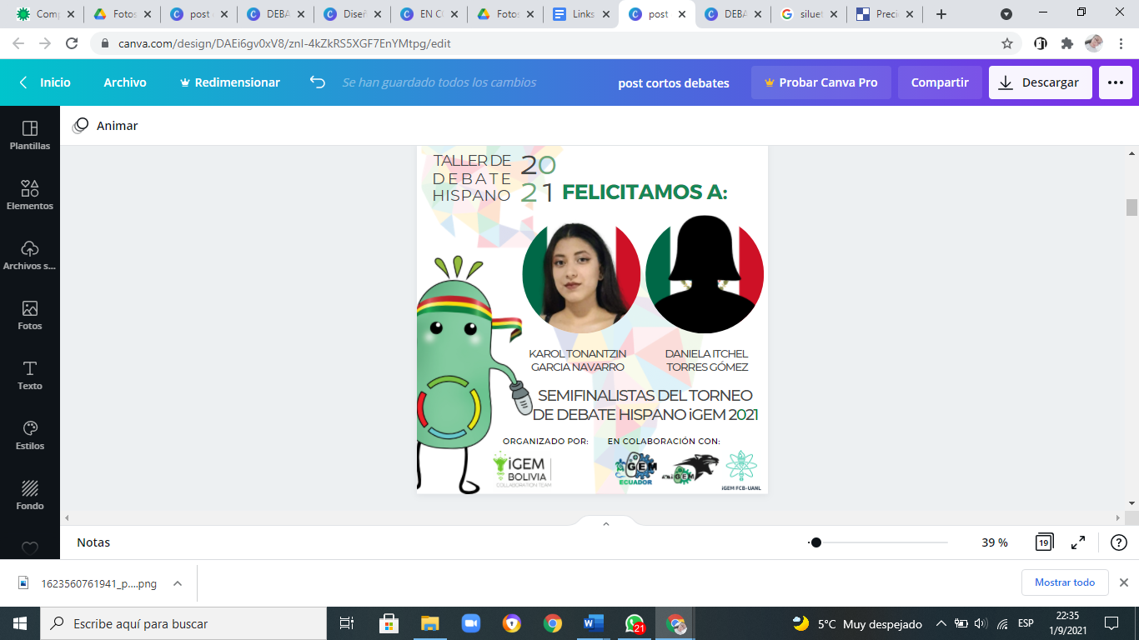* Should Synthetic Biology be restricted for the precaution of bioterrorism? iGEM Bolivia as affirmative and FCB-UANL as negative.

* Is it ethical to use aborted human embryos for experiments? UAM participated as affirmative and SYNTHETIC BIOBOTS as negative.

*SCHEDULE OF*

*THE TOURNAMENT*

GRAND FINALE

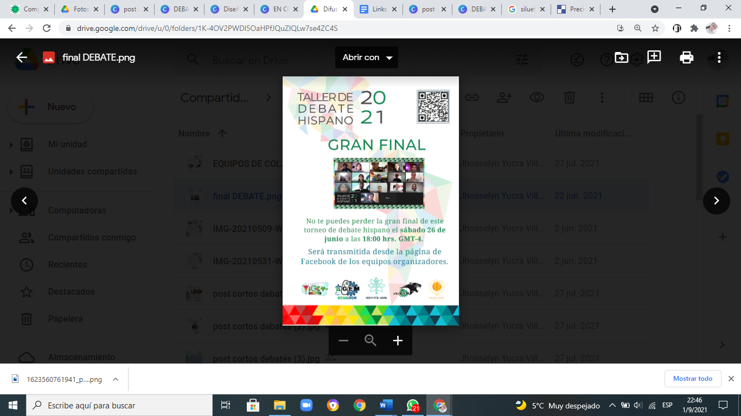In this final we had two Mexican teams: iGEM UAM team represented by Andrea Sánchez and Angel Emanuel Martínez Flores and FCB - UANL team formed by Jorge Alberto Uribe and Julissa Janeth García, who competed for the first place.

The debate allowed for a broad exchange of ideas, questions, rebuttal and defense of arguments between the two teams. The debate was quite intense and ended, declaring the FCB-UANL team the winner of the 2021 Hispanic Debate Tournament.

PARTNERSHIP

Hispanic Discussion Workshop

Handbook “iGEM from Begginers”

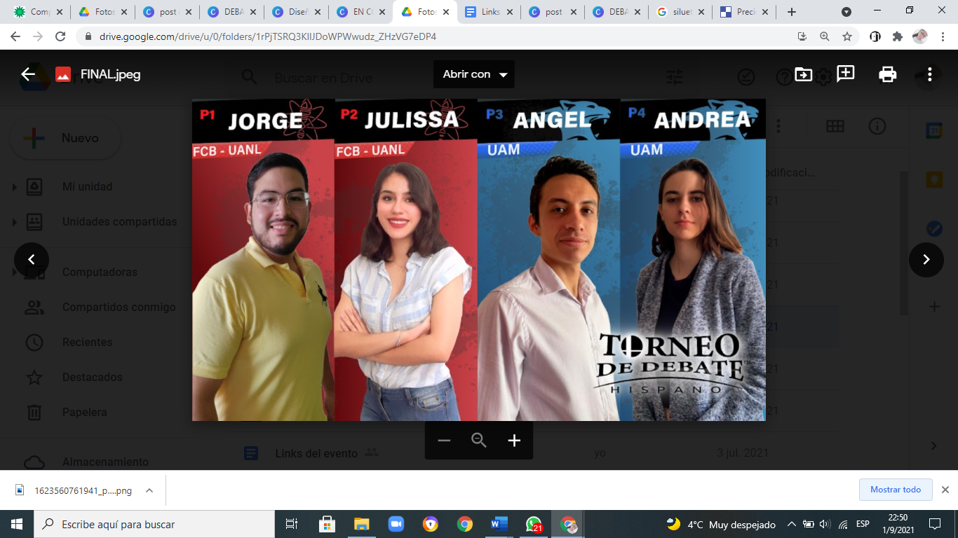

This event was sponsored by Allbiotech which awarded the winning team with a totally free course. It was also possible to make a broadcast in the iGEM TV episode for Latin America where the impact of this event was shown and where the winners shared their experience with all the iGEMers who tuned in to the episode.

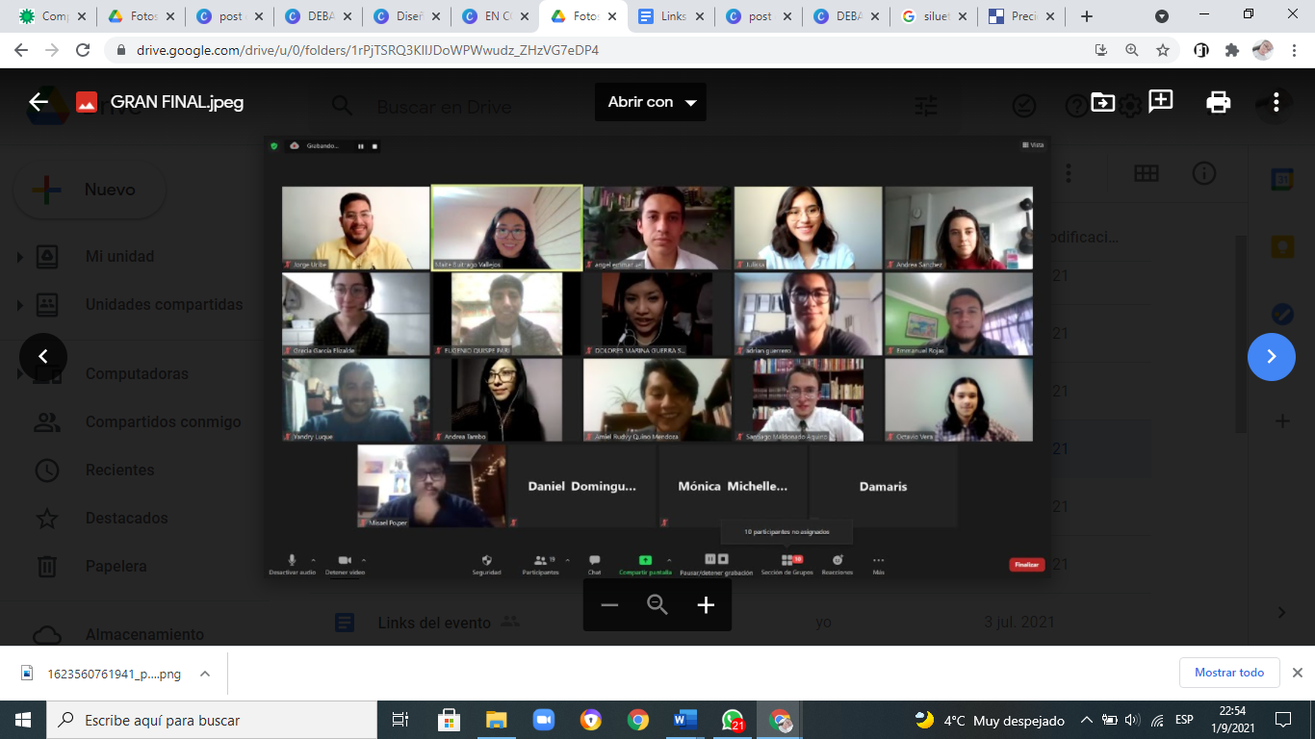

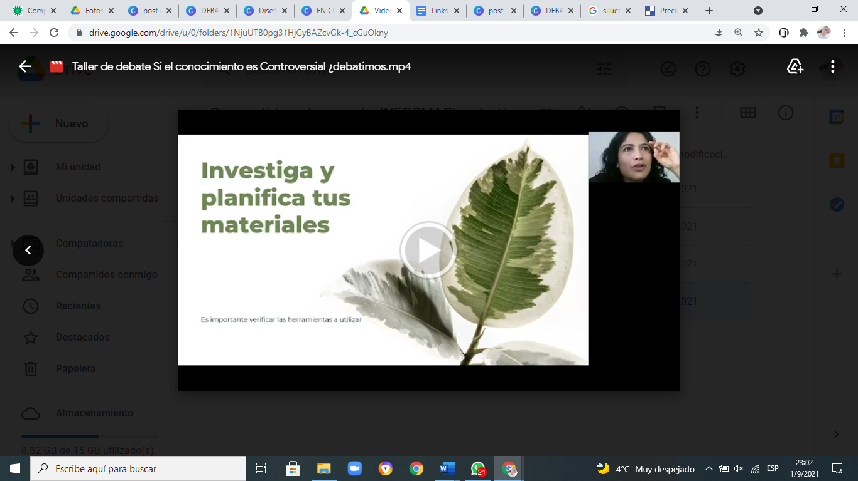

*INFOGRAPHY OF DEBATE TOURNAMENT*

RESULTS

PARTNERSHIP

Hispanic Discussion Workshop

Handbook “iGEM from Begginers”

This activity could be seen thanks to iGEM TV for Latin America, where the impact of this event on the participating iGEMers was shown and where the winners shared their experience, too. In addition, we inspire iGEM UAM to debate with radical movements, such as GreenPeace, to bring controversial issues around Synthetic Biology.

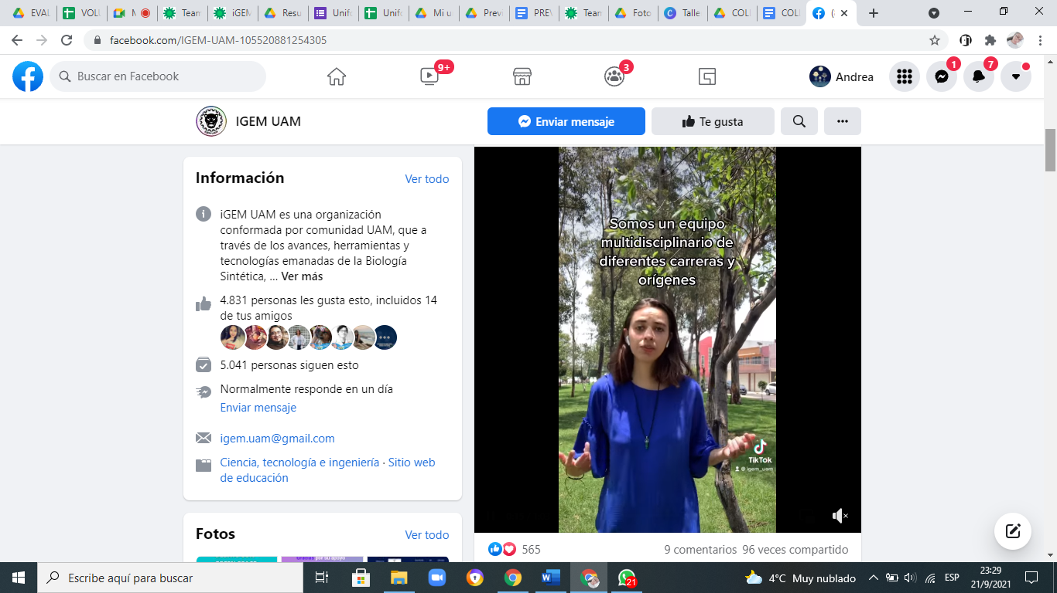

ORGANIZING TEAM AND SUPPORT TEAM

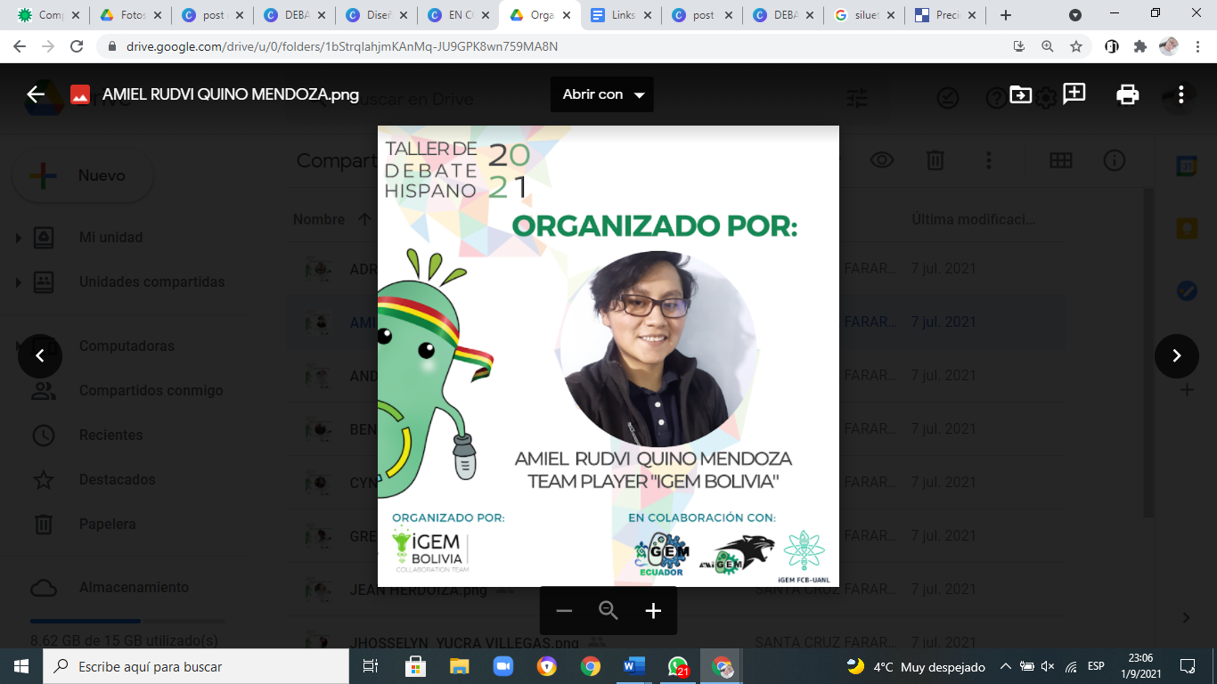All this would not have been possible without the help of all those who participated in this great event contributing their ideas and time to make it happen successfully.

Although the workshop and tournament lasted about a month, the organization of the event was a hard work of months. We thank the iGEM teams who dedicated many hours of work, provided their social media platforms, helped us with the calendar and most of all provided us with an amazing workplace, where we got new friends.

We also want to thank the speakers and judges who helped us supervise the event, always giving us continuous feedback so that all participants can improve their debate skills.

We also thank all the participants who gave their time selflessly to learn more these types of tools and skills to defend their positions in a more informed way.

Finally, we thank all the staff of iGEM Bolivia who helped us in the workshops and in the collection of information throughout the event, they are exceptional people.

*DEBATE TOURNAMENT*

*EXTENSO*

*---SEE ATRIBUTIONS*